Overview
- Indoor Dual Band Dual Concurrent 2+2 802.11BE Access Point
- Supports 2.4GHz 2x2 and 5GHz 2x2 radio circuits
- Achieves up to 5Gbps total wireless throughput
- Equipped with rich flash and SDRAM for dual image, secured boot, and advanced system features
- Ideal for MDUs, hotels, and enterprise deployments
- Includes BLE and Zigbee support for IoT use cases (*SKU-dependent)
- Sleek, compact design that mounts cleanly to wall plates or flat surfaces
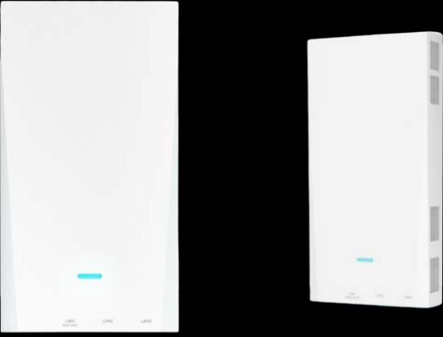

Manufacturer: SonicFi

Specifications
Interface
- WAN Port:
  - 1 × RJ45 Ethernet port
  - Auto-sensing: 10/100/1000/2500 BASE-T
  - Power Input: PoE-PD 802.3at
- LAN Ports:
  - 3 × RJ45 Ethernet ports
  - Auto-sensing: 10/100/1000/2500 BASE-T
  - PoE-PSE: 802.3at

Wi-Fi Radios
- 2.4 GHz Radio
  - Standard: 802.11BE 2x2 (2SS)
  - Max Data Rate: 688 Mbps
- 5 GHz Radio
  - Standard: 802.11BE 2x2 (2SS)
  - Max Data Rate: 4323 Mbps
- Architecture: Dual Band MU-MIMO

Wireless Antenna
- Type: 3 integrated antennas for 2.4G, 5G, and BLE
- Antenna Gain:
  - 2.4GHz: 4 dBi
  - 5GHz: 5 dBi
  - BLE: 1.78 dBi
Physical
- Dimensions: Compact, vertically mounted housing
- Weight:
  - Net: 330g
  - With bracket: 400g
- Mounting:
  - Over-the-socket wall plate mount
  - Generic wall surface mount (kit included)

Environmental Conditions
- Operating Temperature: 0°C to 40°C / 32°F to 104°F
- Storage Temperature: –40°C to +70°C / –40°F to +158°F
- Operating Humidity: 10% to 90% (non-condensing)
- Storage Humidity: 5% to 90% (non-condensing)

Key Features
- High-efficiency Wi-Fi 7 (802.11BE) with MLO and MRU
- All-in-one network and IoT access point with optional BLE and Zigbee
- Dual concurrent radios for high user density performance
- PoE-powered with PoE pass-through LAN port for powering downstream devices
- Toolless installation with universal wall mount options

What’s in the box
Package Content:
- RAP750W-311A Access Point
- Mounting Brackets (Over-the-Socket + Generic)
- Screw and anchor set
- Quick Start Guide
- Regulatory & Compliance Documentation

