Overview
- Indoor L2 Managed Ethernet Switch with built-in LCD screen
- Supports 24 × 10/100/1000Base-T ports
- Includes 2 × 1G/10G SFP+ uplink ports
- All 24 copper ports support IEEE 802.3at PoE (30W)
- Built-in 1.3” LCD touch panel for live device status and diagnostics
- Equipped with smart fan cooling for efficient and quiet operation
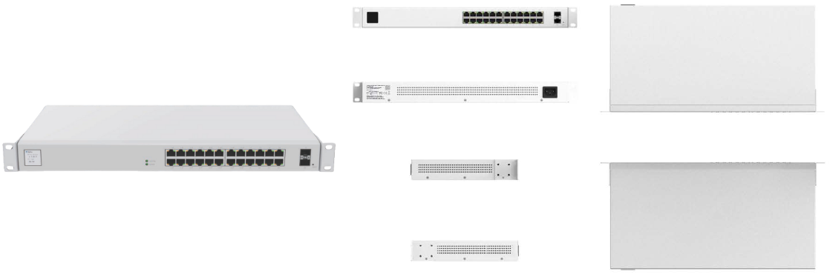
Manufacturer: SonicFi

Specifications
Performance
- Switching Capacity: 88 Gbps
- Forwarding Rate: 65.47 Mpps
Ports
- 10/100/1000Base-T Copper Ports: 24
- SFP+ Uplink Ports (1G/10G): 2
- Power-over-Ethernet (PoE):
  - 24 ports × IEEE 802.3at (30W per port)
LCD Panel
- T Display Size: 1.3”
- Function: Touch panel for real-time status visibility and quick diagnostics
Power & Cooling
- Maximum PoE Power Budget: 370W
- Power Input:
  - AC 100–240V, 50/60Hz
  - Maximum: 4.54A
- Internal PSU: 1 included
- Cooling: Smart Fan
Physical
- Dimensions (H × W × D): 44 × 440 × 230 mm
- Form Factor: 1U rackmount
- Mounting Hardware: Included (brackets, screws)

Environmental Conditions
- Operating Temperature: 0°C to 40°C / 32°F to 104°F
- Operating Humidity: 10% to 95% (non-condensing)
Key Features
- Fan and LCD Panel Combo: Actively cooled unit with a display interface for enhanced visibility
- PoE Support on All Ports: Power multiple IP devices such as APs, cameras, and phones
- Dual SFP+ Uplink Ports: Fiber-ready with flexible 1G/10G support
- Reliable Build: Internal PSU, rack-ready form factor, and robust thermal design

What’s in the box
Package Content:
- RSW226G-2PV Switch
- 1 × Power Cable
- Rackmount Kit (brackets + screws)
- Quick Start Guide
- Regulatory and Safety Documentation

