Overview
- Outdoor Dual Band Dual Concurrent 2+2 802.11BE Access Point
- Supports 2.4GHz 2x2 and 5GHz 2x2 radio circuits
- Delivers physical wireless data rates up to 5Gbps
- Built-in flash and SDRAM memory to support dual image, secured boot, and advanced system features
- Ruggedized IP67-rated enclosure for harsh outdoor environments
- Designed for pole or wall-mounted deployment
- Temperature hardened: –30°C to +65°C operation range
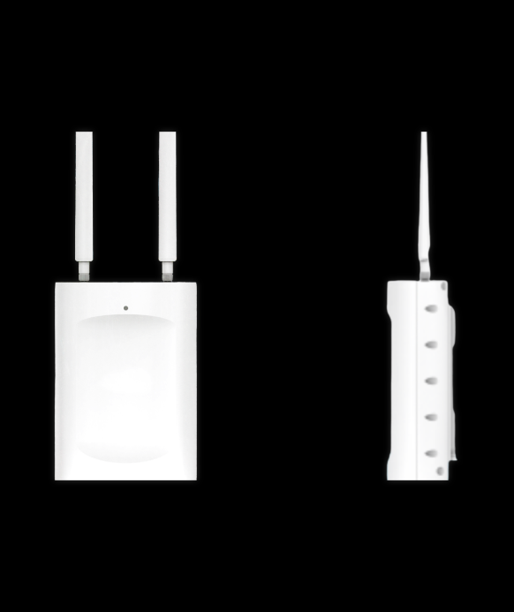
Manufacturer: SonicFi

Specifications
Interface
- WAN Port:
  - 1 x Ethernet port (RJ45)
  - Auto-sensing speeds: 10/100/1000/2500 BASE-T
- PoE Power Input: IEEE 802.3at

Wi-Fi Radios
- 2.4 GHz Radio
  - 802.11BE 2x2 (2SS)
  - HE40 data rate: 688 Mbps
- 5 GHz Radio
  - 802.11BE 2x2 (2SS)
  - EHT240 data rate: 4323 Mbps
- Wi-Fi Architecture: Dual band MU-MIMO
Antennas
- Type:
  - Three integrated antennas for 2.4G, 5G, and Bluetooth
- Gain:
  - RAP750E-H (External Omni):
    - 2.4GHz: 5 dBi max
    - 5GHz: 7 dBi max
  - RAP750E-S (Built-in Sector):
    - 2.4GHz: 12 dBi max
    - 5GHz: 8 dBi max

Physical
- Weight: 1.4 kg (device body only)
- Dimensions: 240 × 170 × 82 mm
- Enclosure: IP67-rated for outdoor durability
Environmental Conditions
- Operating Temperature: –30°C to +65°C / –22°F to +149°F
- Storage Temperature: –40°C to +70°C / –40°F to +158°F
- Operating Humidity: 5% to 90% non-condensing
- Storage Humidity: 5% to 90% non-condensing
Key Features
- High-efficiency Wi-Fi 7 with MLO (Multi-Link Operation) and MRU (Multiple Resource Unit)
- Seamlessly integrates into outdoor smart city, campus, or enterprise network designs
- Enhanced memory and firmware security for future-proof performance
- Designed for easy installation with clearly defined pole and wall mount instructions

What’s in the box
Package Content:
- RAP750E-S Access Point
- Mounting bracket (Pole & Wall compatible)
- Screw & anchor set
- Quick Start Guide
- Regulatory documentation

