Overview
- Indoor Dual Band Dual Concurrent 4x4 802.11AX (Wi-Fi 6) Access Point
- Supports 2.4GHz and 5GHz, each with 4x4 MIMO radio circuits
- Achieves total physical wireless data rates up to 3.55Gbps
- Designed for high-efficiency Wi-Fi 6 environments
- Embedded flash and SDRAM for secured boot and dual image support
- Compact, clean form factor with over-the-socket ceiling mount
- Equipped with PoE-PD (IEEE 802.3at) for simplified installation
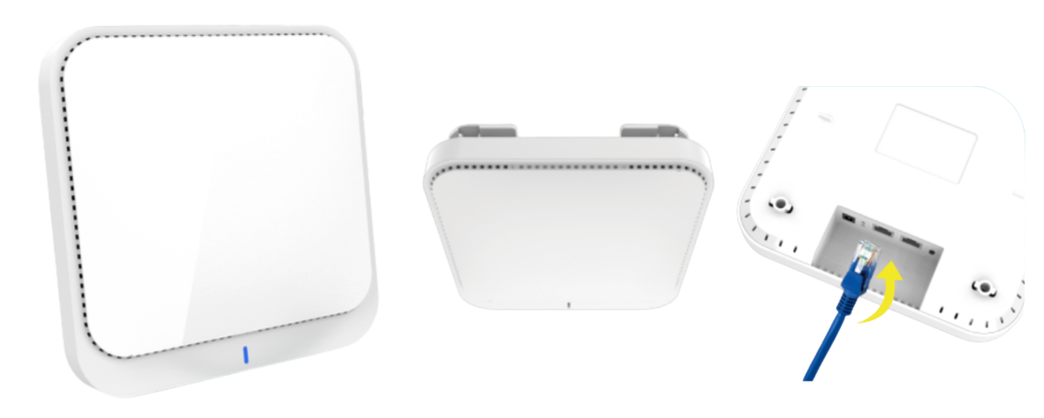
Manufacturer: SonicFi

Specifications
Interface
- WAN Port:
  - 1 × Ethernet (RJ45)
  - Auto-sensing: 10/100/1000/2500 Mbps
  - PoE-PD: IEEE 802.3at
- LAN Port:
  - 1 × Ethernet (RJ45)
  - Auto-sensing: 10/100/1000/2500 Mbps
Wi-Fi Radios
- 2.4 GHz Radio
  - Standard: 802.11AX 4x4
  - Max Data Rate: 1148 Mbps
- 5 GHz Radio
  - Standard: 802.11AX 4x4
  - Max Data Rate: 2402 Mbps
- Architecture: Dual Band MU-MIMO
Antennas
- Type: Embedded internal antennas
- Band Support: 2.4G and 5G
- Gain:
  - 3 dBi (2.4GHz)
  - 3 dBi (5GHz)
Physical
- Weight: 800g (with mounting bracket)
- Form Factor: Rounded square, low-profile design
- Mounting: Over-the-socket ceiling mount kit included
Environmental Conditions
- Operating Temperature: 0°C to 45°C / 32°F to 113°F
- Storage Temperature: –40°C to +70°C / –40°F to +158°F
- Operating Humidity: 5% to 90% non-condensing
- Storage Humidity: 5% to 90% non-condensing
Key Features
- Wi-Fi 6 performance with high user density and low latency
- 4x4 radio configuration on both 2.4GHz and 5GHz bands
- Supports 2.5G uplink and LAN ports, ideal for high-throughput applications
- Designed for modern indoor deployments like enterprise offices, schools, and smart spaces
- Quick and clean ceiling installation without exposed cabling What’s in the box

What’s in the box
Package Content:
- RAP650C Access Point
- Ceiling Mount Bracket & Screws
- Quick Start Guide
- Compliance & Regulatory Documentation

