Overview
- Tri-Band Tri-Concurrent 802.11BE Access Point
- Supports 2.4GHz, 5GHz, and 6GHz radio circuits (2x2 MIMO each)
- Physical wireless data rate: up to 11Gbps
- Integrated six antennas for optimized coverage and performance
- High-efficiency Wi-Fi 7: MLO (Multi-Link Operation), MRU (Multiple Resource Units)
- Ceiling-mount design with sleek, modern housing
- Supports dual image and secured boot for enhanced firmware management and security
- Power options: PoE 802.3at or 12V/2.5A DC

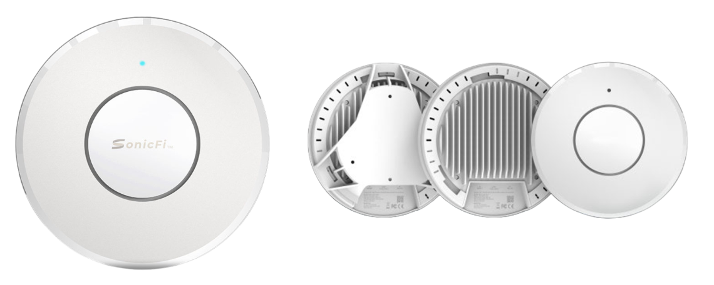

Manufacturer: SonicFi

Specifications
Interfaces:
- Uplink Port:
  - 1 x 10G Ethernet
  - Auto-sensing speeds: 1Gbps / 2.5Gbps / 10Gbps

Wi-Fi Radios
- 2.4 GHz Radio
  - Standard: IEEE 802.11BE
  - Configuration: 2x2 MIMO (2 Spatial Streams)
  - Max Data Rate: 688 Mbps
  - Antenna Gain: 4 dBi

- 5 GHz Radio
  - Standard: IEEE 802.11BE
  - Configuration: 2x2 MIMO (2 Spatial Streams)
  - Max Data Rate: 4323 Mbps
  - Antenna Gain: 5 dBi
- 6 GHz Radio
  - Standard: IEEE 802.11BE
  - Configuration: 2x2 MIMO (2 Spatial Streams)
  - Max Data Rate: 5764 Mbps
  - Antenna Gain: 5 dBi
- Total Antennas: 6 internal antennas (2 per band: 2.4G, 5G, 6G)
- Technology Features: Tri-Band MU-MIMO, High-Efficiency Wi-Fi 7 with MLO and MRU support
Antennas
- Type: Internal, six integrated antennas
- Gain:
  - 4 dBi @ 2.4 GHz
  - 5 dBi @ 5 GHz
  - 5 dBi @ 6 GHz

Power
- Input Options:
  - Power over Ethernet (PoE) 802.3at
  - 12V/2.5A DC
- Power Consumption: Not specified in detail, optimized for low-energy indoor use
Physical
- Mounting Options: Ceiling mount (bracket included)
- Weight:
  - Net: 900g
  - With bracket: 1000g
- Design: Sleek, white form factor; integrates seamlessly in modern office or commercial environments

Environmental Conditions
- Operating Temperature: 0°C to 40°C / 32°F to 104°F
- Storage Temperature: -40°C to 70°C / -40°F to 158°F
- Operating Humidity: 10% to 90% (non-condensing)
- Storage Humidity: 5% to 90% (non-condensing)
Key Features
- High-Efficiency Wi-Fi 7: Delivers blazing speeds and low latency using the latest 802.11BE standard
- Tri-Band Design: Handles dense device environments with dedicated radios per band
- Seamless Mounting: Designed for discrete installation in office or enterprise environments

- Smart Management: Enhanced memory enables secured boot, dual image, and advanced software features
- Next-Gen MU-MIMO: Optimized for high-density deployments and real-time application performance

What’s in the box
Package Content:
- RAP7110C Access Point
- Ceiling mounting bracket and screws
- Quick Start Guide
- Regulatory documentation

