## Overview

* 48 × 10 GbE SFP+ Ports (supporting 1 Gb, 2.5 Gb, 5 Gb, and 10 Gb speeds)
* 6 × 100 GbE QSFP28 Uplink Ports
* Switching Capacity: 2.16 Tbps
* Forwarding Rate: ~600 Mpps

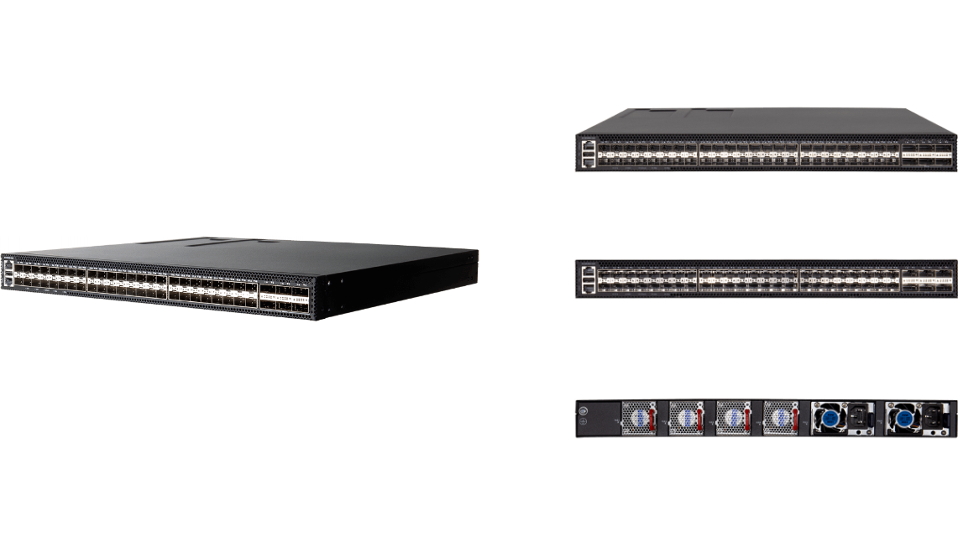

**Manufacturer**: Edgecore

## Specifications

**Interfaces:**

* 48 × multi‑rate 10 GbE SFP+ downlink ports (also support 1 Gb, 2.5 Gb, 5 Gb speeds)
* 6 × 100 GbE QSFP28 uplink ports (with breakout capability to lower speeds)
* Management ports: 1 × RJ‑45 Console, 1 × USB (management), plus standard RJ‑45 Gigabit management port implied by series

**Performance**

* Switching Capacity: 2.16 Tbps
* Forwarding Rate: ~600 Mpps
* DRAM: 4 GB ECC
* Flash: 8 GB eMMC
* MAC Address Table: ~32 K entries

**Power Supply**

* Maximum Power Consumption: ~230 W
* Redundant, hot‑swappable dual power supplies (AC or DC configurations)
* Hot‑swappable fan tray with 1+1 or 3+1 redundancy depending on deployment

**Mechanical**

* Rack: 1 RU, 19″ chassis
* Dimensions: 442 × 420 × 44 mm (≈17.4 × 16.5 × 1.73 in)
* Weight: ~8.86 kg (≈19.5 lb) with full PSU and fan modules installed

**Environmental**

* Operating Temperature: –5 °C to 50 °C (23 °F to 122 °F)
* Storage Temperature: –40 °C to 70 °C (–40 °F to 158 °F)
* Relative Humidity (non‑condensing): 5% to 95%

**L2 / L3‑Lite Capabilities**

* Full suite of L2/L3‑Lite protocols: MSTP, QinQ, VLAN translation, TrTCM, MLAG, ITU‑T G.8032 ERPS (<50 ms convergence), OAM (802.3ah)
* IPv6-ready: includes management, security, and multicast control support
* Multicast features: IGMP/MLD Snooping, MVR (supporting up to 5 multicast VLANs)

**Security & Management**

* Security features: Port Security, DHCP Snooping, IP Source Guard, Dynamic ARP Inspection (DAI), DoS protection
* Management options: CLI (console or Telnet), SNMP v1/v2/v3, intuitive Web UI, and full private MIB support for EMS integration
* ONIE pre-loaded for user-installed NOS (e.g., EdgeCOS, SONiC Lite)

## What’s in the box

**Package Content:**

* ECS5550‑54X switch chassis
* Rack‑mount kit (front and rear brackets with screws)
* AC power cords (if AC PSU selected) or equivalent DC cabling
* Console cable (RJ‑45 to DE‑9)
* Grounding wire
* Documentation (Quick Start Guide and Safety & Regulatory booklet)

## Interface overview

**Interface Overview:**

* Front: 48 × 10 GbE SFP+ ports, 6 × 100 GbE QSFP28 uplink ports
* Rear: Console RJ‑45 port, USB port, AC/DC power connectors, grounding point

**System LEDs:**

* SYS: Green = OK; Blinking = Booting; Yellow = Fault
* MST/STACK: Indicate stack master and active stack mode status
* FAN: Green = Normal; Yellow = Fan Fault
* PSU: Green = Power OK; Yellow = PSU Fault
* Per‑port LEDs: SFP+ green for 10G, orange for lower speeds; QSFP28 green for 100G (or indicate 40G breakout)