## Overview

* 24 or 48 10GbE SFP+ Ports
* 6 100GbE Uplink Ports
* Switching Capacity: 1.68 Tbps
* Forwarding Rate: ~600 Mpps
* Supports 1/2.5/10 GbE downlink speeds

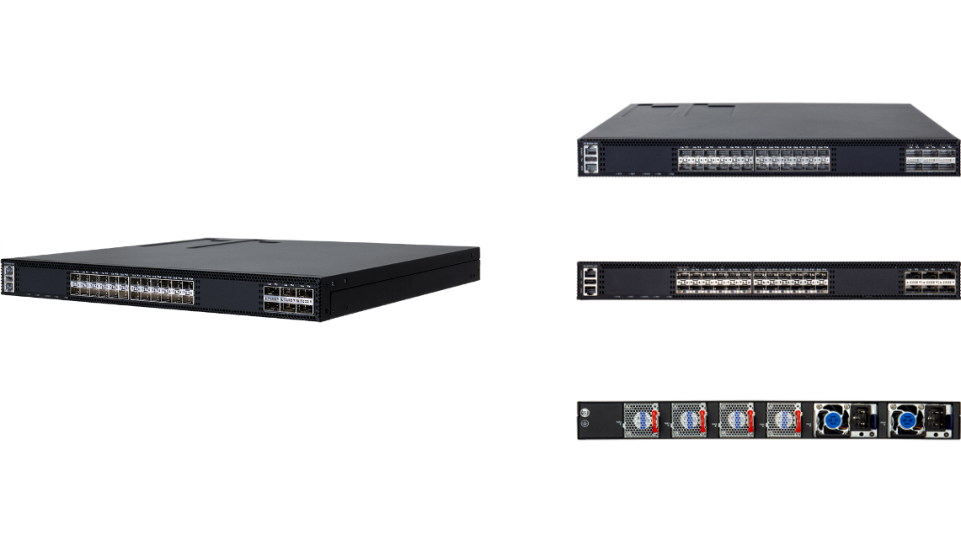

**Manufacturer**: Edgecore

## Specifications

**Interfaces:**

* 24 × 10 GbE SFP+ ports (also support 1 Gb, 2.5 Gb speeds)
* 6 × 100 GbE QSFP28 uplink ports (can operate as breakout to 40 GbE if needed)
* Management ports: 1 × RJ‑45 Gigabit Ethernet, 1 × RJ‑45 Console port, 1 × USB port

**Performance**

* Switching Capacity: 1.68 Tbps
* Forwarding Rate: 600 Mpps
* DRAM: 4 GB ECC
* eMMC Flash Memory: 8 GB eMMC
* MAC Address Table: ~32K entries

**Power Supply**

* Max Power Consumption: ~200 W
* Power supplies: 1+1 redundant, hot‑swappable, available in AC or DC options
* Fans: 3+1 redundant, hot‑swappable cooling module

**Mechanical**

* Rack mount: 1U, 19” rack
* Dimensions: 442 × 420 × 44 mm (≈17.4 × 16.5 × 1.7 in)
* Weight: 8.8 kg (≈19.4 lb) with dual PSUs and full fan modules installed

**Environmental**

* Operating Temperature: –5 °C to 50 °C (23–122 °F)
* Storage Temperature: –40 °C to 70 °C
* Humidity (non‑condensing): 5% to 95%

**L2 / L3‑Lite Capabilities**

* Comprehensive L2/L3‑Lite protocol support including MSTP, LLDP, QinQ, VLAN translation, TrTCM, OAM (802.3ah), MLAG, etc.
* ITU‑T G.8032 ERPS (Ethernet Ring Protection Switching) with sub‑50 ms convergence for high availability

**Security & Management**

* Security features: Port Security, DHCP Snooping, IP Source Guard, Dynamic ARP Inspection (DAI), DoS protection
* Multicast control: IGMP/MLD Snooping, MVR (Multicast VLAN Registration) up to 5 multicast VLANs
* IPv6 robust support: Management, security, multicast control
* Management interfaces: CLI (console/telnet), SNMP v1/v2/v3, Web UI with private MIB support
* ONIE installer pre‑loaded (no OS image shipped; user may install compatible NOS such as EdgeCOS or SONiC‑Lite)

## What’s in the box

**Package Content:**

* ECS5550‑30X switch chassis
* Rack‑mount kit (front/rear brackets & screws)
* 2 × AC power cords (or DC cabling if chosen)
* Console cable (RJ‑45 to DB‑9)
* Grounding wire
* Documentation (Quick Start Guide, Safety & Regulatory information)

## Interface overview

**Interface Overview:**

* 24 × 10G SFP+ downlink ports
* 6 × 100G QSFP28 uplink ports
* Management RJ‑45, console RJ‑45, USB port
* Grounding point, AC power sockets (and optional DC PSUs)

**System LEDs:**

* SYS: Green = OK; Flashing Green = Booting; Yellow = Fault
* MST: Green = Stack Master
* STACK: Green = Stack Mode Active
* FAN: Green = Normal; Yellow = Fan Fault
* PSU: Green = Power OK; Yellow = PSU Fault
* SFP+ LEDs: Green = 10G; Orange = 1G or 2.5G
* QSFP28 LEDs: Green = 100G; may also indicate 40G breakout performance