Overview
- WiFi: 6 Dual Band 2x2 (2.4/5GHz)
- Uplink: 1 x 2.5Gb (PoE in)
- Pole mount
- IP67

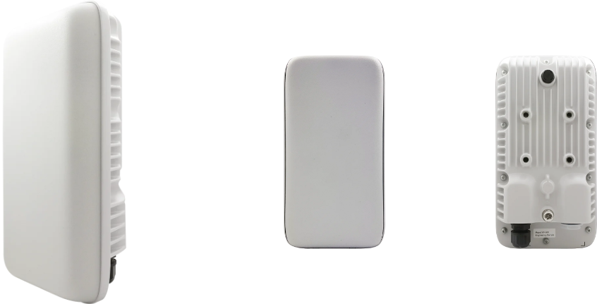

Manufacturer: Actiontec

Specifications
Radios:
- Concurrent Dual-Band 2.4 GHz & 5 GHz
- 802.11ax 2x2 MU-MIMO supporting up to 1.774 Gbps data rate
- Bluetooth Low Energy (BLE) 5.0
Interfaces:
- Uplink: 1 x 2.5Gb RJ-45, PoE in 802.3at PoE (PD)
Physical
- Dimension (W x D x H): 260 mm (W) x 140 mm (D) x 71 mm (H)
- Input Voltage
  - 50V ~ 57V, 802.3 at PoE (PD)
- Weight: 1.5 Kg (without bracket)
- 1 X Tri-Color LED (R/G/B)
- Buttons: Restart
- Environmental Conditions
  - Operating Temperature: -40°F (-40°C) to 149°F (65°C)
  - Operating Humidity: 5% to 95% non-condensing
  - Elevations: 86kPa～106kPa altitude
  - Dustproof and Waterproof: IP67
- Power Consumption: < 20 W
- Antenna Pattern (build-in Antennas)
  - Polarization: Horizontal/Vertical
  - Peak Gain: 5/7 dBi
  - Efficiency (Avg): >70%(2400-2500MHz)
  - Efficiency (Avg): >75%(4940-5850NHz)
  - Return Loss: 10dB
  - Isolation: 20dB
  - H-Beam Width: 120 degree
  - V-Beam Width: 60 degree
- Mounting options
  - Wall mount
  - Pole mount

Radio
- Standards 802.11ax (Wi-Fi 6) concurrent dual-band 2.4 & 5 GHz
- Supported Data Rates
  - 802.11b: 1, 2, 5.5, 11 Mbps
  - 802.11a/g: 6, 9, 12, 18, 24, 36, 48, 54 Mbps
  - 802.11n: MCS0~MCS7
  - 802.11ac: MCS0~MCS9
  - 802.11ax: MCS0~MCS11
- Channelization
  - 2.4 GHz: 20 / 40 MHz
  - 5 GHz: 20 / 40 / 80MHz
- Frequency Range
  - 2.4000GHz~2.4835GHz
  - 5.150~5.250,5.250~5.350,5.470~5.725, 5.725~5.850 GHz
- Certifications

Regulatory Compliance
- Safety
  - NRTL Listed 62368-1 (US & CA)
  - CB with IEC/EN 62368-1 (Basic safety certificate for worldwide marketing)
  - GB 9254 -2008(Class B of Product)

  - EN55032, CISPR 32:2010,EN55024, CISPR 24:2010
  - Level 4; EN61000-4-2, FCC Part 15B
  - WEEE 2002/96/EC recyclable materials requirements

