Overview
- 2.4G 4x4 Wi-Fi (802.11b/g/n/ac/ax ) 20/40MHz channel width
- 5G 4x4 Wi-Fi (802.11a/n/ac/ax) 20/40/80MHz channel width
- 6G 4x4 Wi-Fi (802.11ax), 20/40/80/160MHz channel width
- 4 x 2.4G/5G Integrated dual-band antennas
- 1 x 2.5GE LAN
- 1 x 5GE WAN with 802.3bt PoE (Full Functionality) or 802.3at PoE (USB port disabled)
- 1 x Reset button
- 1 x USB PD Type-C 15V2A
- Ceiling or wall installation

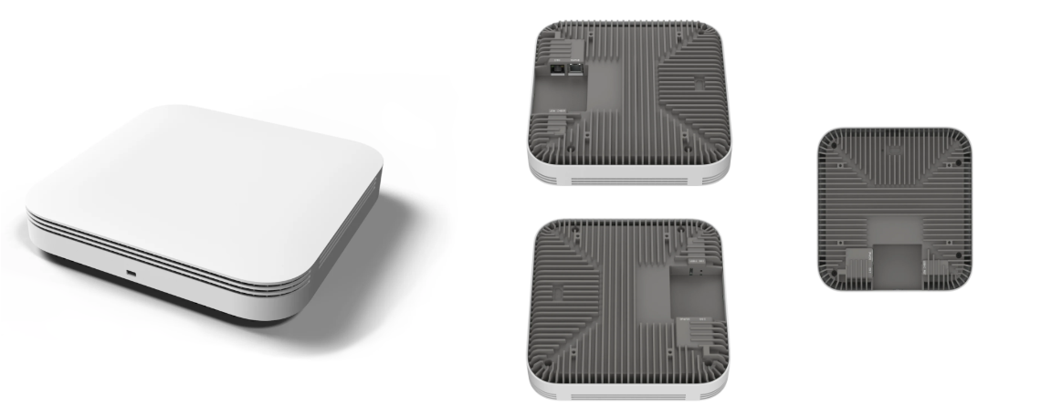

Manufacturer: Actiontec

Specifications
Radios:
- Concurrent Tri-Band 2.4 GHz, 5 GHz & 6 GHz
- 802.11ax 4x4 MU-MIMO supporting up to 8.4 Gbps data rate
- Bluetooth Low Energy (BLE) 5.0
Interfaces:
- Uplink: 1 x 5Gb RJ-45, PoE in 802.3bt (full functionality) or 802.3at (USB port disabled)
- LAN: 1 x 2.5Gb RJ-45
- 1 x USB Type-C connector
Physical
- Dimension (W x D x H): 225 mm (W) x 225 mm (D) x 38 mm (H)
- Input Voltage
  - USB PD Input: 15V / 2A
  - PoE input: 42.5 ~ 57V, 802.3at/bt PoE (PD)
- Weight: 1.6 Kg
- 1 X Tri-Color LED (R/G/B)
- Buttons: Restart
- Environmental Conditions
  - Operating Temperature: 32°F (0°C) to 113°F (45°C)
  - Operating Humidity: 5% to 95% non-condensing
  - Elevations: 86kPa～106kPa altitude
  - Dustproof and Waterproof: IP20
- Power Consumption: < 30 W
- Antenna Pattern (build-in Antennas)
  - 2400-2500MHz – Vertical/Horizontal ≥3 Gain (dBi)
  - 4940-5850MHz – Vertical/Horizontal ≥3 Gain (dBi)
- Mounting options
  - Ceiling mount
  - Wall mount

Radio
- Standards 802.11ax (Wi-Fi 6) concurrent dual-band 2.4 & 5 GHz
- Supported Data Rates
  - 802.11b: 1, 2, 5.5, 11 Mbps
  - 802.11a/g: 6, 9, 12, 18, 24, 36, 48, 54 Mbps
  - 802.11n: MCS0~MCS7
  - 802.11ac: MCS0 ~ MCS9
  - 802.11ax: MCS0 ~ MCS11
- Channelization
  - 2.4 GHz: 20 / 40 MHz
  - 5 GHz: 20 / 40 / 80MHz
  - 6 GHz: 20 / 40 / 80 / 160MHz
- Frequency Range
  - 2.4000GHz~2.4835GHz
  - 5.150~5.250,5.250~5.350,5.470~5.725, 5.725~5.850 GHz
  - 5.925~7.125GHz
- Certifications

Regulatory Compliance
- Safety
  - NRTL Listed 62368-1 (US & CA)
  - CB with IEC/EN 62368-1 (Basic safety certificate for worldwide marketing)
  - GB 9254 -2008(Class B of Product)
  - EN55032, CISPR 32:2010
  - EN55024, CISPR 24:2010
  - CCC (optional)
  - SRRC (optional)
  - FE (optional)
  - FCC (optional)
  - RoHS 2011/65/EU compliant (RoHS 11 compliant, no Pb)
  - WEEE 2002/96/EC recyclable materials requirements

