Overview
- Wi-Fi 6 Dual Band 2x2 (2.4/5GHz)
- Uplink: 1 x 1Gb (PoE in)
- LAN: 1 x 1Gb (RJ-45)

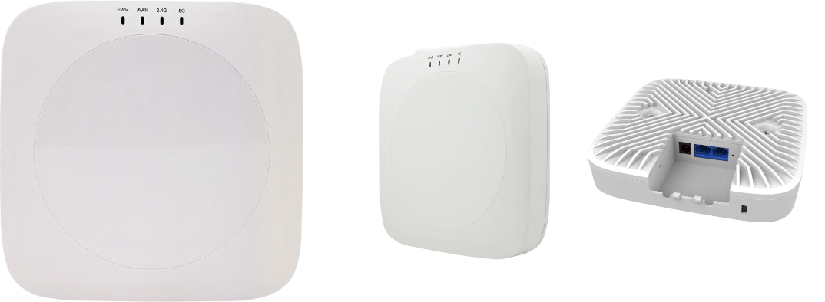

Manufacturer: Actiontec

Specifications
Radios:
- Concurrent Dual-Band 2.4 GHz & 5 GHz
- 802.11ax 2x2:2 UL and DL MU-MIMO supporting up to 1.8 Gbps data rate
- Bluetooth Low Energy (BLE) 5.0
Interfaces:
- Uplink: 1 x 10/100/1000-T Ethernet RJ-45, with 802.3at (PD)
- LAN: 1 x 10/100/1000-T Ethernet RJ-45
Physical
- Dimension (W x D x H): 158 mm (W) x 158 mm (D) x 28 mm (H)
- Input Voltage
  - DC Input: 12V / 1.5A
  - PoE input: 50V ~ 57V, 802.3 at PSE
- Weight: 0.3 kg
- 4 X LED Indicator (PWR/WAN/2.4G/5G)
- Buttons: Restart

- Environmental Conditions
  - Operating Temperature: 32°F (0°C) to 113°F (45°C)
  - Operating Humidity: 5% to 95% non-condensing
  - Elevations: 86kPa～106kPa altitude
  - Dustproof and Waterproof: IP30
- Power Consumption: xxx W max
- Antenna Pattern (build-in Antennas)
  - 2400-2500MHz – Vertical/Horizontal ≥3 Gain (dBi)
  - 4940-5850MHz – Vertical/Horizontal ≥3 Gain (dBi)
- Mounting options
  - Ceiling mount

Radio
- Standards 802.11ax (Wi-Fi 6) concurrent dual-band 2.4 & 5 GHz
- Supported Data Rates
  - 802.11b: 1, 2, 5.5, and 11Mbps
  - 802.11g: 6, 9, 12, 18, 24, 36, 48, and 54Mbps
  - 802.11a: 6, 9, 12, 18, 24, 36, 48 and 54Mb/s
  - 802.11n HT20/ HT40: MCS0~MCS15 (400/ 800ns GI)
  - 802.11ac VHT20/VHT40: MCS0 ~ MCS9(400/ 800ns GI)
  - 802.11ax HE20/ HE40: MSC0 ~ MCS11(400/ 800ns GI)
  - 802.11a: 6, 9, 12, 18, 24, 36, 48 and 54Mb/s
  - 802.11n HT20/ HT40: MCS0~MCS15(400/ 800ns GI)
  - 802.11ac VHT20/VHT40/VHT80: MCS0 ~ MCS9(400/ 800ns GI)
  - 802.11ax HE20/ HE40/HE80: MSC0 ~ MCS11(400/ 800ns GI)
- Channelization
  - 2.4 GHz: 20 / 40 MHz
  - 5 GHz: 20 / 40 / 80MHz
- Frequency Range
  - 2.4000 –2.4835 GHz
  - 5.150~5.250,5.250~5.350,5.470~5.725, 5.725~5.850 GHz
- Certifications

Regulatory Compliance
- Safety
  - NRTL Listed 62368-1 (US & CA)
  - CB with IEC/EN 62368-1 (Basic safety certificate for worldwide marketing)
  - GB 9254 -2008(Class B of Product)
  - EN55032, CISPR 32:2010
  - EN55024, CISPR 24:2010
  - CCC (optional)
  - SRRC (optional)
  - FE (optional)
  - FCC (optional)
  - RoHS 2011/65/EU compliant (RoHS 11 compliant, no Pb)
  - WEEE 2002/96/EC recyclable materials requirements

