Overview
- Wi-Fi: 6 Dual Band 2x2 (2.4/5GHz)
- Uplink: 1 x 1Gb (RJ-45) with PoE In
- LAN: 2 x 1Gb (RJ-45)

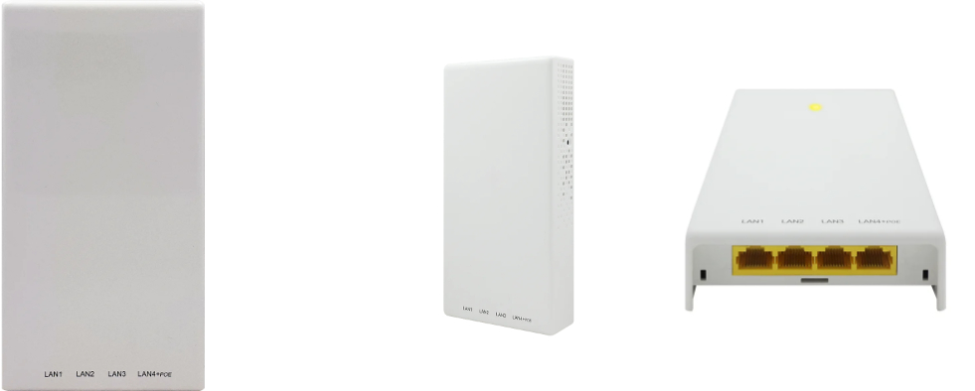

Manufacturer: Actiontec

Specifications
Radios:
- Concurrent Dual-Band 2.4 GHz & 5 GHz
- 802.11ax 2x2 MU-MIMO supporting up to 2.974 Gbps data rate
- Bluetooth Low Energy (BLE) 5.1/ ZigBee
Interfaces:
- Uplink: 1 x 1Gb RJ-45, PoE in 802.3bt PoE (PD)
- LAN: 4 x 1Gb RJ-45, one with 802.3af PoE (PSE)
Physical
- Dimension (W x D x H): 180 mm (W) x 89.5 mm (D) x 29.3 mm (H)
- Input Voltage - PoE input:
  - 42.5V~ 57V , 802.3bt PoE (PD), with LAN port supporting 802.3af PoE(PSE)
  - 37V ~ 57V, 802.3 af PoE (PD), with restricted functions
- Weight: 0.28Kg (without bracket)
- 1 X Tri-Color LED (R/G/B)
- Buttons: Restart
- Environmental Conditions
  - Operating Temperature: 32°F (0°C) to 104°F (40°C)
  - Operating Humidity: 5% to 95% non-condensing
  - Elevations: 86kPa～106kPa altitude
  - Dustproof and Waterproof: IP30
- Power Consumption: < 12W, without 802.3af PoE (PSE)
- Antenna Pattern (build-in Antennas)
  - 2400-2500MHz – Vertical/Horizontal ≥3 Gain (dBi)
  - 4940-5850MHz – Vertical/Horizontal ≥3 Gain (dBi)
- Mounting options
  - Wall mount

Radio
- Standards 802.11ax (Wi-Fi 6) concurrent dual-band 2.4 & 5 GHz
- Supported Data Rates
  - 802.11b: 1, 2, 5.5, 11 Mbps
  - 802.11g: 6, 9, 12, 18, 24, 36, 48, 54 Mbps
  - 802.11a: 6, 9, 12, 18, 24, 36, 48, 54 Mbps
  - 802.11n: HT20/ HT40: MCS0~MCS15
  - 802.11ac: VHT20/VHT40/VHT80: MCS0 ~ MCS9
  - 802.11ax: HE20/ HE40/HE80/HE160: MSC0 ~ MCS11
- Channelization
  - 2.4 GHz: 20 / 40 MHz
  - 5 GHz: 20 / 40 / 80 /160MHz
- Frequency Range
  - 2.4000GHz~2.4835GHz
  - 5.150~5.250,5.250~5.350,5.470~5.725, 5.725~5.850 GHz

Regulatory Compliance
- Safety
  - NRTL Listed 62368-1 (US & CA)
  - CB with IEC/EN 62368-1 (Basic safety certificate for worldwide marketing)
  - GB 9254 -2008(Class B of Product) , EN55032, CISPR 32:2010
  - EN55024, CISPR 24:2010
  - RoHS 2011/65/EU compliant (RoHS 11 compliant, no Pb)
  - WEEE 2002/96/EC recyclable materials requirements

