Overview
- 2.4G 2x2 Wi-Fi (802.11ax ) 20/40MHz channel width
- 5G 2x2 Wi-Fi (802.11ax) 20/40/80/160MHz channel width
- 11ax 2x2(2SS) HE40 with data rate of 574Mbps
- 11ax 2x2(2SS) HE160 with data rate of 2400Mbps
- 1 x 4GE LAN Uplink
- 1 x Reset button
- Generic Wall Mount and Over the socket wall mount

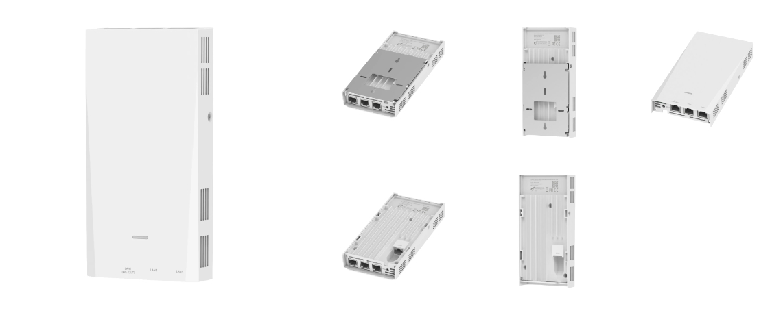

Manufacturer: SonicFi

Specifications
Radios:
- Concurrent Dual-Band 2.4 GHz, 5 GHz
- 802.11ax 2x2 UL MU-MIMO supporting up to 3 Gbps data rate
Interfaces:
- Uplink: 1 x 4Gb RJ-45, 10/100/1000 Mbps Ethernet Port (802.3at/af POE input)
- Downlink: 1 x 10/100/1000 Mbps Ethernet Port(802.3af POE output) , 2 x 10/100/1000 Mbps Ethernet Ports
- LAN: Ethernet Port (RJ-45) * 3, 802.3af * 1 PoE-PSE, 802.3at * 1 PoE-PD
Physical
- Dimension (W x D x H): 90 mm (W) x 25 mm (D) x 178 mm (H)
- Input Voltage
  - PoE input: 44 ~ 57V, 802.3at/af PoE
- Weight: 0.39 Kg
- 1 X Di-Color LED (W/B)
- Buttons: Factory reset
- Environmental Conditions
  - Operating Temperature: 32°F (0°C) to 104°F (40°C)
  - Operating Humidity: 10% to 90% non-condensing
- Power Consumption: 13.5 W max
- Antenna Pattern (build-in Antennas)
  - 2.4Ghz - 3.5 (dBi) max
  - 5Ghz - 4.5 (dBi) max
- Mounting options
  - Generic Wall Mounting
  - Over the Socket Wall Mounting

Radio
- Standards 802.11ax:2x2 (Wi-Fi 6) concurrent dual-band 2.4 & 5 GHz
- Supported Data Rates
  - 802.11b: 1, 2, 5.5, 11Mbps
  - 802.11a/g: 6, 9, 12, 18, 24, 36, 48, 54 Mbps
  - 802.11n: 6.5-300 Mbps (20 / 40 MHz)
  - 802.11ac : 6.5-867 Mbps (20 / 40 / 80 MHz)
  - 802.11ax: 3.6-574 Mbps (2.4 GHz, 20 / 40 MHz)
  - 802.11ax: 3.6-2402 Mbps (5 GHz, 20/ 40 / 80 / 160 MHz )
- Channelization
  - 2.4 GHz: 20 / 40 MHz
  - 5 GHz: 20 / 40 / 80 / 160MHz
- Frequency Range
  - 802.11b: 1, 2, 5.5, 11Mbps
  - 802.11a/g: 6, 9, 12, 18, 24, 36, 48, 54 Mbps
  - 802.11n: 6.5-300 Mbps (20 / 40 MHz)
  - 802.11ac : 6.5-867 Mbps (20 / 40 / 80 MHz)
  - 802.11ax: 3.6-574 Mbps (2.4 GHz, 20 / 40 MHz)
  - 802.11ax: 3.6-2402 Mbps (5 GHz, 20/ 40 / 80 / 160 MHz )
- Certifications

Regulatory Compliance
- Safety
  - NRTL Listed 62368-1 (US & CA)
  - CB with IEC/EN 62368-1 (Basic safety certificate for worldwide marketing)
  - GB 9254 -2008(Class B of Product)
  - EN55032, CISPR 32:2010
  - EN55024, CISPR 24:2010
  - CCC (optional)
  - SRRC (optional)
  - FE (optional)
  - FCC (optional)
  - RoHS 2011/65/EU compliant (RoHS 11 compliant, no Pb)
  - WEEE 2002/96/EC recyclable materials requirements

What’s in the box
Package Content:
- RAP630W-311G Indoor AP access
- Wall Mount Set
- Native Wall Mount
- Over the Socket
- Quick Installation Guide

Interface overview
- System LEDs
- Factory reset button
- 1 x 10/100/1000 Mbps Uplink 4Gb Ethernet Port (802.3at/af POE input)
- 1 x 10/100/1000 Mbps Downlink 4Gb Ethernet Port (802.3af POE output)
- 2 x 10/100/1000 Mbps Downlink 4Gb Ethernet Port
- Auto-sensing linking speed(10/100/1000BASE-T)
- PoE LED and Mode button
- Ethernet port(RJ-45) * 1

System LEDs
- Flashing White / Off every 0.5 sec: The device is initialing and booting up
- Steady White: The device is awaiting adoption
- Steady Blue: The device is adopted and is in normal operating mode
- Quickly Flashing White / Blue: The device is currently being upgraded - don't interrupt the process
- Blue and Flashing off every 5 sec: Access point has lost network connectivity and is searching for wireless link

