Overview
- Wi-Fi 6 Dual Band 2x2 (2.4/5GHz)
- Uplink: 1 x 2.5Gb (RJ-45) with PoE-In
- LAN: 1 x 1Gb (RJ-45)
- PoE-In (802.3at) or DC Input: 48V

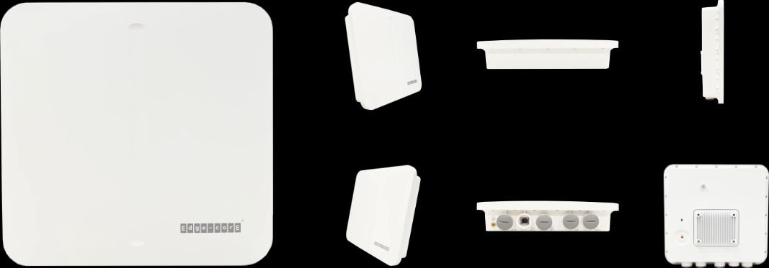

Manufacturer: EdgeCore

Specifications
Radios:
- Concurrent Dual Band 2.4 GHz, 5 GHz
- 2×2:2 UL and DL MU-MIMO supporting up to 3Gbps data rate
- Bluetooth Low Energy (BLE) 4.5dBi
Interfaces:
- Uplink: 1 x 10/100/1000/2.5GBase-T Ethernet, Auto MDIX, RJ-45 with 802.3at PoE
- LAN: 1 x 10/100/1000Base-T Ethernet, Auto MDIX, RJ-45
- Console: 1 x RJ-45 Port
Physical
- Dimensions (L x W x H): 11.15in x 11.55in x 2.79in (28.34 cm x 29.34 cm x 7.1 cm)

- Power options
  - DC Input: 48 VDC (DC terminal block)
  - PoE input: 802.3at compliant (PSE injector is not included in standard package)
- Weight: 3.80 lb (1.725 kg)
- LED Indicator: 1 x tri-color LED (Power, Cloud, Uplink)
- Buttons: 1 x Restart / Reset
- Environmental Conditions
  - Operating Temperature: -40°C (-40°F) to 60°C (140°F)
  - Operating Humidity: 5% to 95% non-condensing
- Power Consumption: 21.12 W max
- Antenna
  - Type: Built-in omni-directional antennas with 20-degree down tilt
  - Gain: 5 dBi (2.4 GHz), 6 dBi (5 GHz), 4.5 dBi (Bluetooth Low Energy)
- Mounting options
  - Pole mount (standard bracket including hose clamp)
  - Wall mount (standard bracket)

Radio
- Standards 802.11ax (Wi-Fi 6) concurrent dual-band 2.4 , 5 GHz
- Supported Data Rates
  - 802.11b: 1, 2, 5.5, 11 Mbps
  - 802.11a/g: 6, 9, 12, 18, 24, 36, 48, 54 Mbps
  - 802.11n: 6.5 –300 Mbps (20 / 40 MHz)
  - 802.11ac: 6.5 –867 Mbps (20 / 40 / 80 MHz
  - 802.11ax: 3.6 –574 Mbps (2.4 GHz, 20 / 40 MHz)
  - 802.11ax: 3.6 –2402 Mbps (5 GHz, 20 / 40 / 80 / 160 MHz)
  - 802.11ax: 3.6 –2402 Mbps (6 GHz, 20 / 40 / 80 / 160 MHz)
- Radio Chains: 2 x 2
- Spatial Streams: 2; MU-MIMO support
- Aggregate Conducted Transmit Power
  - 2.4 GHz: Up to 26 dBm
  - 5 GHz: Up to 25 dBm
- Regulatory domain specific: 2.4–2.4835 GHz (US, Canada, ETSI, Japan, TW) 5.15–5.25 GHz (lower band) US/Canada, TW 5.725–5.825 GHz (upper band) US/Canada, TW Europe 5.15–5.25 GHz, 5.25–5.35, 5.47–5.725 GHz Japan 5.15–5.25 GHz, 5.25–5.35, 5.47–5.73 GHz
- Channelization
  - 2.4 GHz: 20 / 40 MHz
  - 5 GHz: 20 / 40 / 80 / 160 MHz
- Frequency Range
  - 2.401 –2.483 GHz
  - 5.170 –5.835 GHz
- Operating Channels
  - 2.4 GHz: 1-11 (US), 1-13 (Europe), 1-13 (Japan)
  - 5 GHz : 36-165 (US), 36-140 (Europe), 100-144(Japan)

Regulatory Compliance
- Radio: EN300 328 V2.2.2 (2019-07) EN301 893 V2.1.1(2017-05) 47 CFR FCC Part 15.247 47 CFR FCC Part 15.407 IC RSS-247 Issue 2 and RSS-Gen Issue 5 NCC LP0002 Section 4.10.1 (2020-07-01) NCC LP0002 Section 5.7 (2020-07-01) MIC certification Rule, Article 2 Paragraph 1 Item 19 MIC certification Rule, Article 2 Paragraph 1 Item 19-3
- Emissions: EN 301 489-1 V2.1.1 (2017-02) EN 301 489-17 V3.1.1 (2017-02) EN 55032:2015 AS/NZS CISPR 32:2015, Class B 47 CFR FCC Rules and Regulations Part 15 Subpart B, Class B Digital Device ICES-003, Issue 7 Class B CNS 13438 terminal equipment design certification, Article 3, Article 4, Article 6, Article 9 and Article 34 regulation
- Safety: Low Voltage Directive IEC 62368-1:2014; and/or EN 62368-1:2014+A11:2017; and/or BS 62368-1:2014+A11:2017 CNS 14336-1 IEC/EN 62368-1, IEC/EN 60950-1
- Taiwan RoHS: CNS 15663

What’s in the box
Package Content:
- OAP-101 Wifi 6 access point
- Mounting bracket and 4 x M6 screws
- DC terminal plug
- 3 x Cable glands
- 2 x Steel-band clamps for pole mount (2.5 inch diameter max.)
- Screw kit—4 screws and 4 plugs
- QR code card

Interface overview
- 48 VDC power input or 802.3at PoE
- Restart/Reset button
  - A quick press restarts the system
  - Press and hold for 5 seconds resets to factory default
- Console port (RJ-45)
- LAN1 Port: 1 Gbps connections to LAN devices
  - Port LED: On (link), Blinking (traffic)
- Uplink (PoE) Port: 2.5 Gbps connections to 802.3at PoE
  - Port LED: On (link), Blinking (traffic)

- System LED Indicators
  - 2.4G: On (radio on), Blinking (traffic)
  - 5G: On (link), Blinking (traffic)
- Power/Cloud/Uplink Tri-Color LED
  - Yellow green: On (power OK), Blinking (boot up)
  - Blue: On (cloud managed)
  - Purple: Blinking (uplink activity in cloud managed mode)
  - Orange: Blinking (uplink activity in stand-alone mode)
- Kensington lock slot

