Overview
- 24x 1G (RJ-45) LAN ports PoE+
- 4 x 1G/10G (SFP+) Uplink ports
- PoE budget 370W
- 1 x 1G (RJ-45) Management port

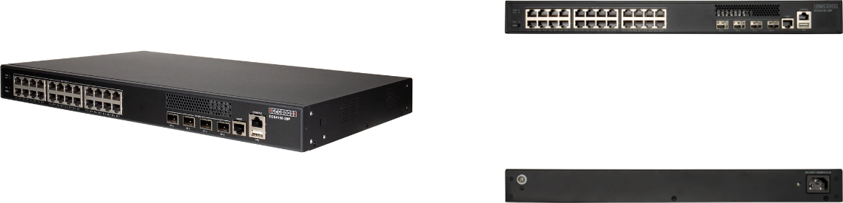

Manufacturer: Edgecore

Specifications
Interfaces:
- Uplink: 4 x 10Gb SFP+
- LAN: 24 x 1G RJ-45 PoE+
- Console: 1 x RJ-45 Port
- Management: 1 x 1G RJ-45 Port
Physical
- Dimension (W x D x H): 17.32 x 11.02 x 1.73 inches (44 x 28 x 4.4 cm)
- Input Voltage: 100-240 VAC, 50-60 Hz
- Weight: 10.47 lbs (4.75Kg)
- Environmental Conditions
  - Operating Temperature: 23°F (-5°C) to 113°F (45°C)
  - Operating Humidity: 5% to 95% non-condensing
- Power Consumption: 30W (without PoE), 450W Max
- Mounting options: Rack mount 19
- Certifications: FCC Class A, CE, Safety Compliance: CB, Safety Compliance: UL
- Performance
  - Switching Capacity: 128 Gpbs
  - Forwarding Rate: 95 Mpps
  - MAC Address Table Size: 16K
  - Jumbo Frames: 10 KB
- Supported transceiver
  - 1000BASE-SX/LX and 10GBASE-DAC/AOC Cable
  - 10GBASE-SR/LR/RJ45
- PoE
  - Total PoE budget: 370 Watts in total, 57V max/0.6A max per port
  - IEEE 802.3at or IEEE 802.3af
  - Auto disable aſter exceeding power budget: Yes
  - Dynamic Power Allocation: Yes
  - PoE Power Budget: 370W

Regulatory Compliance
- Emissions: EN 55032:2015/A1:2020 EN IEC 61000-3-2:2019/A1:2021 EN 61000-3-3:2013/A2:2021 FCC Class A VCCI-CISPR 32:2016 Class A BSMI (CNS 15936)
- Safety: UL (CSA 22.2 No 62368-1 & UL62368-1) CB (IEC/EN 62368-1) BSMI (CNS 15598-1)
- Taiwan RoHS: CNS 15663
- Immunity: IEC 61000-4-2/3/4/5/6/8/11 EN 55035:2017/A11:2020
- Electromagnetic Compatibility
  - CE Mark
  - FCC Class A
  - CISPR Class A
  - BSMI

What’s in the box
Package Content:
- L2+/L3 Lite Gigabit Ethernet (PoE) Switch
- Rack mounting kit- 2 brackets and 6 or 8 screw
- Power cord
- Four Adhesive rubber feet
- Console cable-RJ-45 to DE-9
- Documentation-Quick Start Guide(this document) and Safety and Regulatory information

Interface overview
Interface Overview:
- System LEDs
- Management Port ,Console port and USB Port
- 24 x 10/100/1000M RJ-45 ports
- 4 x 1/10G SFP+ ports
- PoE LED and Mode button
- Ground screw
- AC power socket

System LEDs:
- Sys: Green (OK), Blinking Green (booting)
- PWR: Green (OK)
- RJ-45 1G Ports: Green/Blinking (link/activity)
- SFP+/SFP28 Ports: Green/Blinking (link/activity)

