Overview
- 8 x Multi-Gig (1/2.5G) LAN Ports with PoE++
- 2 x SFP+ (1G/10G) Uplink Ports
- Up to 30W on 8 ports or 60W on 4 ports for a total of 240W
- 80G switching capacity

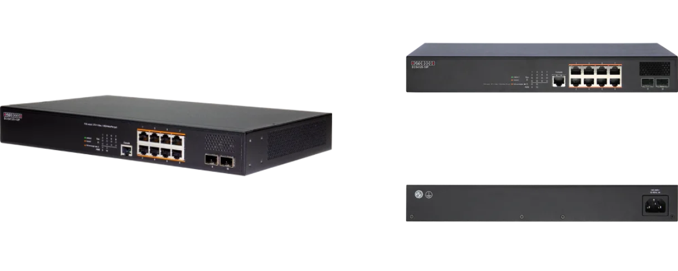

Manufacturer: Edgecore

Specifications
Interfaces:
- Uplink: 2 x 10Gb SFP+
- LAN: 8 x 2.5Gb RJ-45 PoE++ (up to 60w)
- Console: 1 x RJ-45 Port
Physical
- Dimension (W x D x H): 12.99 x 8.18 x 1.86 inches (33 x 20.79 x 4.73 cm )
- Input Voltage: 100-240 VAC, 50-60 Hz, 1.0A
- Weight: 5.31 lbs (2.41Kg)
- Environmental Conditions
  - Operating Temperature: 32°F (0°C) to 122°F (50°C)
  - Operating Humidity: 10% to 90% non-condensing
- Power Consumption: 20W (without PoE), 370W Max
- Mounting options: Rack mount 19
- Certifications: FCC Class A, CE, Safety Compliance: CB, Safety Compliance: UL
- Performance
  - Switching Capacity: 80 Gpbs
  - Forwarding Rate: 59.52 Mpps
  - MAC Address Table Size: 16K
  - Jumbo Frames: 12 KB
- Supported transceiver
  - 1000BASE-SX/LX/EX/ZX and 1000BASE-T (RJ-45)
  - 10GBASE-SR/LR/ER/ZR
- PoE
  - Total PoE budget: 240
  - 30W on 8 ports or 60W on 4 ports
  - IEEE 802.3bt (60 W) or IEEE 802.3at/ 802.3af
  - Auto disable aſter exceeding power budget: Yes
  - Dynamic Power Allocation: Yes
  - PoE Power Budget: 240W

Regulatory Compliance
- Emissions: EN 55032:2015/A1:2020 EN IEC 61000-3-2:2019/A1:2021 EN 61000-3-3:2013/A2:2021 FCC Class A VCCI-CISPR 32:2016 Class A BSMI (CNS 15936)
- Safety: UL (CSA 22.2 No 62368-1 & UL62368-1) CB (IEC/EN 62368-1) BSMI (CNS 15598-1)
- Taiwan RoHS: CNS 15663
- Immunity: IEC 61000-4-2/3/4/5/6/8/11 EN 55035:2017/A11:2020
- Electromagnetic Compatibility
  - CE Mark
  - FCC Class A
  - CISPR Class A
  - BSMI

What’s in the box
Package Content:
- 2.5G L2 Ultra PoE + Switch
- Rack mounting kit- 2 brackets and 8 screw
- Power cord
- Four Adhesive rubber feet
- Console cable-RJ-45 to DE-9
- Documentation-Quick Start Guide(this document) and Safety and Regulatory information

Interface overview
Interface Overview:
- System LEDs
- Console port
- 8x 10/100/1G/2.5G RJ-45 PoE ports
- 2x 1/10G SFP+ ports
- Ground screw
- AC power socket

System LEDs:
- 8x 10/100/1G/2.5G RJ-45 PoE ports
- 2x 1/10G SFP+ ports
- Ground screw
- AC power socket

