Overview
- 8 x RJ-45 10/100/1000 Ports ( Upto 30W)
- 8 x PoE Ports
- 2 x 1G SFP Uplink Ports
- 1 x RJ-45 Console Port

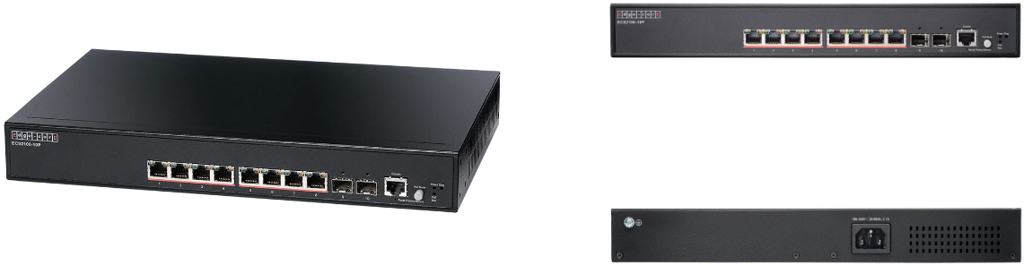

Manufacturer: Edgecore

Specifications
Interfaces:
- Uplink: 2 x 1G SFP Uplink Ports
- LAN: 8 x 10/100/1000BASE-T RJ45 PoE Ports
- Console: 1 x RJ-45 Port
Physical
- Dimension (W x D x H): 13 x 8.03 x 1.67 inches (33 cm x 20.4 cm x 4.26 cm)
- Input Voltage: 100-240 V AC, 50-60 Hz
- Weight: 5.29 lbs (2.4Kg)
- Environmental Conditions
  - Operating Temperature: 32°F (0°C) to 104°F (40°C)
  - Operating Humidity: 10% to 90% non-condensing
- Power Consumption: 160W
- Mounting options: Rack mount 13
- Certifications: FCC Class A, CE, Safety Compliance: CB, Safety Compliance: UL
- Performance
  - Switching Capacity: 20 Gpbs
  - Forwarding Rate: 14.9 Mpps
  - MAC Address Table Size: 8K
  - Jumbo Frames: 10 KB
  - Flash Memory: 32MB
  - DRAM: 256MB
- Supported transceiver
  - 1000BASE-SX/LX/EX/ZX
  - 1000BASE-T(RJ45)
- PoE
  - Total PoE budget: 30W (IEEE 802.3at) on 4 ports or 15.4W (IEEE 802.3af) on 8 ports
  - Auto disable aſter exceeding power budget: Yes
  - Dynamic Power Allocation: Yes

Regulatory Compliance
- Emissions: EN 55032:2015/A1:2020 EN IEC 61000-3-2:2019/A1:2021 EN 61000-3-3:2013/A2:2021 FCC Class A VCCI-CISPR 32:2016 Class A BSMI (CNS 15936)
- Safety: CSA (CSA 22.2 NO 60950-1 & UL 60950-1), CB (IEC/EN60950-1)
- Taiwan RoHS: CNS 15663
- Immunity: IEC 61000-4-2/3/4/5/6/8/11 EN 55035:2017/A11:2020
- Electromagnetic Compatibility
  - CE Mark
  - FCC Class A
  - CISPR Class A
  - BSMI

What’s in the box
Package Content:
- ECS-2100-10P 10 Port Switch
- Power cord
- Rack mounting kit- 2 brackets and 8 screws
- Four Adhesive rubber feet
- Console cable-RJ-45 to DE-9
- Documentation-Quick Start Guide(this document) and Safety and Regulatory information

Interface overview
Interface Overview:
- System LEDs
- Console port
- 8x 10/100/1G/RJ-45 PoE ports
- 2x 1G SFP ports
- Ground screw
- AC power socket

System LEDs:
- Sys: Green (OK), Blinking Green (booting), Orange(fault)
- PWR: Green (OK), Orange (maximum PoE budget)
- RJ-45 1G Ports: Green/Blinking (link/activity), Orange (PoE link)
- SFP+ 10G Ports: Green (10G), Orange (1G)

