Overview
- Wi-Fi 6 Dual Band 2x2 (2.4/5 GHz)
- Uplink: 1 x 1Gb (RJ-45) with PoE-In (802.3at)
- LAN: 1 x 1Gb (RJ-45)
- PoE-In (802.3at) or DC Input: 12V / 2.0A
- Supports BLE and Zigbee for IoT integration
- Concurrent support for up to 512 devices

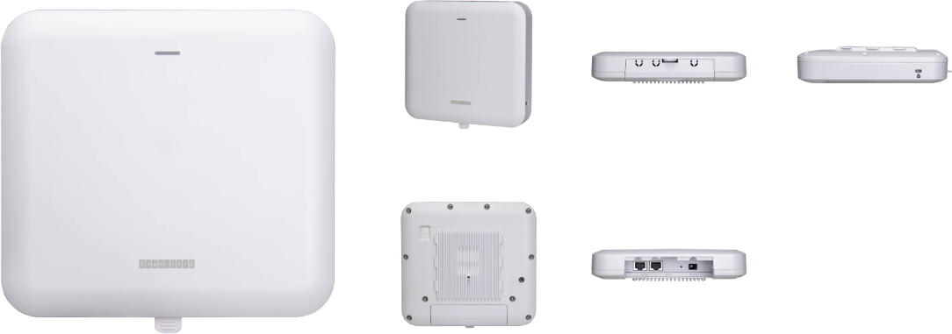

Manufacturer: EdgeCore

Specifications
Radios:
- Concurrent Tri-Band 2.4 GHz, 5 GHz, & 5 GHz
- 802.11ax 2x2:2 MU-MIMO supporting up to 2.4 Gbps data rate
- Bluetooth Low Energy (BLE) 5.2 (IEEE 802.15.1) / Zigbee
Interfaces:
- Uplink: 1 x 10/100/1000Base-T Ethernet, Auto MDIX, RJ-45 with 802.3at PoE
- LAN: 1 x 10/100/1000Base-T Ethernet, Auto MDIX, RJ-45
Physical
- Dimensions (L x W x H): 6.69 in x 7.28 in x 1.55 in (17.0 cm x 18.5 cm x 3.945 cm)

- Power options
  - DC Input: 12V / 2.0A (Adapter AC Input: 100–240 VAC, 50-60 Hz DC Output: 12 VDC, 2 A)
  - PoE input: 802.3at compliant - 22.4 W max, 48 VDC–55 VDC; 802.3at-compliant
- Weight: 1.38 lb (0.63 kg)
- 3 X LED Indicator (2.4G-WiFi / 5G-WiFi / Power)
- Buttons: Restart
- Environmental Conditions
  - Operating Temperature: -4°F (-20°C) to 140°F (60°C)
  - Operating Humidity: 5% to 95% non-condensing
- Power Consumption: 21.4 W max
- Antenna
  - Type: 3 x Built-in antenna (2 x 2.4 GHz & 5 GHz, 1 x Bluetooth Low Energy)
  - Gain: 4.8 dBi(2.4 GHz), 6 dBi(5 GHz), 4.6 dBi(BLE)
- Mounting options
  - Wall
  - Ceiling
  - T-bar mount (Mounting kit included)
  - Pole mount
  - Anti-theft: 1 x Kensington lock slot

Radio
- Standards: 802.11ax (Wi-Fi 6) concurrent dual-band 2.4 & 5 GHz
- Supported Data Rates
  - 802.11b: 1, 2, 5.5, 11 Mbps
  - 802.11a/g: 6, 9, 12, 18, 24, 36, 48, 54 Mbps
  - 802.11n: 6.5 –300 Mbps (20 / 40 MHz)
  - 802.11ac: 6.5 –867 Mbps (20 / 40 / 80 MHz)
  - 802.11ax: 3.6 –574 Mbps (2.4 GHz, 20 / 40 MHz)
  - 802.11ax: 3.6 –2400 Mbps (5 GHz, 20 / 40 / 80 MHz)
- Radio Chains: 2 x 2
- Spatial Streams: 2; MU-MIMO support
- Aggregate Conducted Transmit Power
  - 2.4 GHz: Up to 26 dBm
  - 5 GHz: Up to 26 dBm
- Regulatory domain specific: 2.4–2.4835 GHz (US, Canada, ETSI, Japan, TW) 5.15–5.25 GHz (lower band) US/Canada, TW 5.725–5.825 GHz (upper band) US/Canada, TW Europe 5.15–5.25 GHz, 5.25–5.35, 5.47–5.725 GHz Japan 5.15–5.25 GHz, 5.25–5.35, 5.47–5.73 GHz

- Channelization
  - 2.4 GHz: 20 / 40 MHz
  - 5 GHz: 20 / 40 / 80 MHz
- Frequency Range
  - 2.400 –2.483 GHz
  - 5.150 –5.850 GHz
- Operating Channels
  - 2.4 GHz: 1-11 (US), 1-13 (Europe), 1-13 (Japan)
  - 5 GHz: 36-165 (US), 36-140 (Europe), 36-144 (Japan)

Regulatory Compliance
- Radio: EN300 328 V2.2.2 (2019-07) EN301 893 V2.1.1(2017-05) 47 CFR FCC Part 15.247 47 CFR FCC Part 15.407 IC RSS-247 Issue 2 and RSS-Gen Issue 5 NCC LP0002 Section 4.10.1 (2020-07-01) NCC LP0002 Section 5.7 (2020-07-01) MIC certification Rule, Article 2 Paragraph 1 Item 19 MIC certification Rule, Article 2 Paragraph 1 Item 19-3
- Emissions: EN 301 489-1 V2.1.1 (2017-02) EN 301 489-17 V3.1.1 (2017-02) EN 55032:2015 AS/NZS CISPR 32:2015, Class B 47 CFR FCC Rules and Regulations Part 15 Subpart B, Class B Digital Device ICES-003, Issue 7 Class B CNS 13438 terminal equipment design certification, Article 3, Article 4, Article 6, Article 9 and Article 34 regulation
- Safety: Low Voltage Directive IEC 62368-1:2014; and/or EN 62368-1:2014+A11:2017; and/or BS 62368-1:2014+A11:2017 CNS 14336-1 IEC/EN 62368-1, IEC/EN 60950-1
- Taiwan RoHS: CNS 15663

What’s in the box
Package Content:
- EAP-111 access point
- AC power adapter with international socket converter
- Mounting bracket accessory
- Mounting bracket security screws
- Screw kit (4 screws and 4 wall plugs)
- Pole mount accessory
- QR code card

Interface overview
- 12 VDC power input
- Restart/Reset Button
  - A quick press restarts the system
  - Press and hold for 5 seconds to reset to factory default
- USB port (reserved for future use)
- LAN Port: 1 Gbps connection to LAN devices
  - Port LED: On (link), Blinking (traffic)
- Uplink (PoE) Port: 1 Gbps connection to 802.3at PoE
  - Port LED: On (link), Blinking (traffic)
- System LED Indicators
  - 2.4G: On (radio on), Blinking (traffic)
  - 5G: On (radio on), Blinking (traffic)
  - Power/Status: On (power OK), Blinking (boot up)
- Kensington lock slot

