Overview
- Wi-Fi 7 Tri-Band 2x2 (2.4/5/6 GHz)
- 1 x 5GbE (PoE-In)
- 1 x 1GbE (RJ-45)

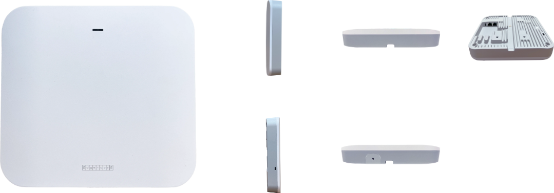

Manufacturer: EdgeCore

Specifications
Radios:
- Concurrent Tri-Band 2.4 GHz, 5 GHz, & 6 GHz
- 802.11be (Wi-Fi 7) 2x2:2 UL/DL MU-MIMO supporting up to 9.34 Gbps aggregated data rate
- Bluetooth Low Energy (BLE), Zigbee, Thread

Interfaces:
- Uplink: 1 x 5GBase-T Ethernet, Auto MDIX, RJ-45 with 802.3at PoE
- LAN: 1 x 10/100/1000Base-T Ethernet, Auto MDIX, RJ-45
Physical
- Dimensions (L x W x H): 7.05 in x 7.68 in x 1.38 in (17.9 cm x 19.5 cm x 3.5 cm)
- Power options
  - PoE Input: 802.3at compliant
- Weight: 2.87 lb (0.907 kg)
- LED Indicators: Power, 2.4 GHz, 5 GHz, 6 GHz
- Buttons: Reset
- Environmental Conditions
  - Operating Temperature: 32¬∞F (0¬∞C) to 122¬∞F (50¬∞C)
  - Operating Humidity: 5% to 95% non-condensing
- Power Consumption: 23.58 W max
- Antenna
  - Type: Built-in antennas
  - Gain: 5 dBi (2.4 GHz), 6 dBi (5 GHz), 6 dBi (6 GHz), 4.78 dBi (BLE)
- Mounting options
  - Wall
  - Ceiling
  - T-bar mount (Mounting kit included)

Radio
- Standards: 802.11be (Wi-Fi 7) concurrent tri-band 2.4 GHz, 5 GHz, & 6 GHz
- Supported Data Rates
  - 802.11b: 1, 2, 5.5, 11 Mbps
  - 802.11a/g: 6, 9, 12, 18, 24, 36, 48, 54 Mbps
  - 802.11n: 6.5 - 300 Mbps (20 / 40 MHz)
  - 802.11ac: 6.5 - 1733 Mbps (20 / 40 / 80 MHz)
  - 802.11ax: 3.6 - 574 Mbps (2.4 GHz, 20 / 40 MHz)
  - 802.11ax: 3.6 - 2400 Mbps (5 GHz, 20 / 40 / 80 MHz)
  - 802.11be: Up to 9.34 Gbps aggregated (2.4 GHz, 5 GHz, 6 GHz)
- Radio Chains
  - 2.4 GHz: 2x2
  - 5 GHz: 2x2
  - 6 GHz: 2x2
- Spatial Streams
  - 2.4 GHz: 2; MU-MIMO support
  - 5 GHz: 2; MU-MIMO support
  - 6 GHz: 2; MU-MIMO support
- Aggregate Conducted Transmit Power
  - 2.4 GHz: Up to 23 dBm
  - 5 GHz: Up to 26 dBm
  - 6 GHz: Up to 26 dBm
- Regulatory domain specific: 2.4-2.4835 GHz (US, Canada, ETSI); 5.15-5.25 GHz (lower band) US/Canada, Europe; 5.725-5.825 GHz (upper band) US/Canada; 6.0-7.125 GHz
- Channelization
  - 2.4 GHz: 20 / 40 MHz
  - 5 GHz: 20 / 40 / 80 / 160 MHz
  - 6 GHz: 20 / 40 / 80 / 160 / 320 MHz
- Frequency Range
  - 2.400 - 2.4835 GHz
  - 5.150 - 5.850 GHz
  - 6.000 - 7.125 GHz

- Operating Channels
  - 2.4 GHz: 1-11 (US), 1-13 (Europe), 1-13 (Japan)
  - 5 GHz: 36-165 (US), 36-140 (Europe), 36-144 (Japan)
  - 6 GHz: Varies by region
- Certifications: FCC, CE, LVD, NCC, BSMI, VCCI, JATE, TELEC, IC, C-Tick, Philippines, Thailand

Regulatory Compliance
- Radio: EN300 328 V2.2.2 (2019-07) EN301 893 V2.1.1(2017-05) 47 CFR FCC Part 15.247 47 CFR FCC Part 15.407 IC RSS-247 Issue 2 and RSS-Gen Issue 5 NCC LP0002 Section 4.10.1 (2020-07-01) NCC LP0002 Section 5.7 (2020-07-01) MIC certification Rule, Article 2 Paragraph 1 Item 19 MIC certification Rule, Article 2 Paragraph 1 Item 19-3
- Emissions: EN 301 489-1 V2.1.1 (2017-02) EN 301 489-17 V3.1.1 (2017-02) EN 55032:2015 AS/NZS CISPR 32:2015, Class B 47 CFR FCC Rules and Regulations Part 15 Subpart B, Class B Digital Device ICES-003, Issue 7 Class B CNS 13438 terminal equipment design certification, Article 3, Article 4, Article 6, Article 9 and Article 34 regulation
- Safety: Low Voltage Directive IEC 62368-1:2014; and/or EN 62368-1:2014+A11:2017; and/or BS 62368-1:2014+A11:2017 CNS 14336-1 IEC/EN 62368-1, IEC/EN 60950-1
- Taiwan RoHS: CNS 15663

What’s in the box
Package Content:
- EAP-105 Access point
- 2 x Mounting bracket security screws
- Mounting bracket accessary
- Ceiling plate
- Screw kit-4 screws and 4 plugs
- QR code card

Interface overview
- 12 VDC power input
- Restart/Reset button
  - A quick press restarts the system
  - Press and hold for 5 seconds to reset to factory default settings
- USB 2.0 port (reserved for future use)
- LAN Port: 1 x 1 Gbps connection to LAN devices
- Uplink (PoE) Port: 1 x 5 Gbps connection to 802.3at PoE LAN devices
- System LED Indicators
  - Uplink (PoE): On (link), Blinking (traffic)
  - 2.4G: On (radio on), Blinking (traffic)
  - 5G: On (radio on), Blinking (traffic)
  - 6G: On (radio on), Blinking (traffic)
  - Status: On (power OK), Blinking (boot up)

