Overview
- Wi-Fi 6 Dual Band 2x2 (2.4/5GHz)
- Uplink: 1 x 2.5Gb (RJ-45) with PoE-In
- LAN: 4 x 1Gb (RJ-45) – 1 port provides PoE out
- Passthrough RJ-45 connector

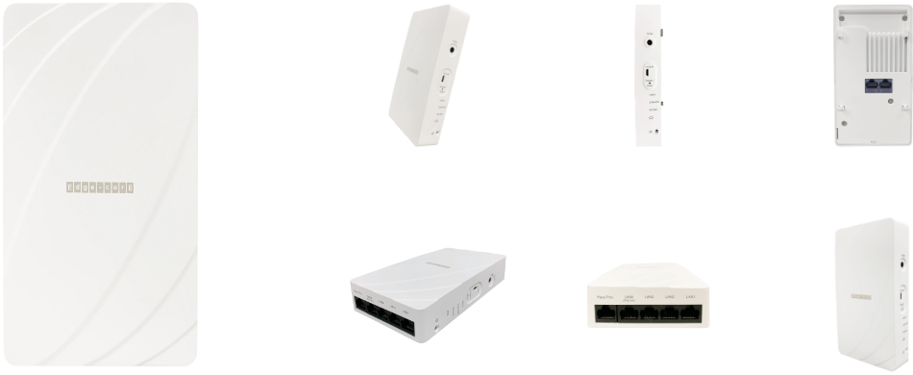

Manufacturer: EdgeCore

Specifications
Radios:
- Concurrent Dual-Band 2.4 GHz & 5 GHz
- 802.11ax 2x2:2 UL MU-MIMO supporting up to 3 Gbps data rate
- Bluetooth Low Energy (BLE) and ZigBee support

Interfaces:
- Uplink: 1 x 10/100/1000-T Ethernet, Auto MDIX, RJ-45 with standard PoE input
- LAN: 4 x 10/100/1000-T Ethernet, Auto MDIX, RJ-45
- Pass-Thru: 1 x pass-through port from rear to bottom
- USB: 1 x Micro-USB Port

Physical
- Dimensions (L x W x H): 160.5 mm (L) x 89.5 mm (W) x 34 mm (H)
- Power options
  - DC Input: 12V / 2.0A (Adapter AC Input: 100–240 VAC, 50-60 Hz DC Output:
12 VDC, 2 A)
  - PoE input: 802.3at/af compliant - 22.4 W max, 48 VDC–55 VDC; 802.3at-compliant
- Weight: 1 lb (0.45 kg)
- 5 X LED Indicator (Power, Cloud Status, 5G-WiFi, 2.4G-WiFi / uplink)
- Buttons: Restart
- Environmental Conditions
  - Operating Temperature: 32°F (0°C) to 113°F (45°C)
  - Operating Humidity: 5% to 95% non-condensing
- Power Consumption: 12.9 W max
- Antenna
  - Type: 5 x Built-in antenna (2 x 2.4 GHz, 2 x 5 GHz, 1 x Bluetooth Low Energy)
  - Gain: 3.9 dBi (2.4 GHz), 5.2 dBi(5 GHz), 4 dBi(BLE)
- Mounting options
  - Wallplate (standard bracket)
  - Wallmount (standard bracket)
  - Desktop (optional stand)
  - Anti-theft: 1 x screw lock

Radio
- Standards 802.11ax (Wi-Fi 6) concurrent dual-band 2.4 & 5 GHz
- Supported Data Rates
  - 802.11b: 1, 2, 5.5, 11 Mbps
  - 802.11a/g: 6, 9, 12, 18, 24, 36, 48, 54 Mbps
  - 802.11n: 6.5 -300 Mbps (20 / 40 MHz)
  - 802.11ac: 6.5 -867 Mbps (20 / 40 / 80 MHz
  - 802.11ax: 3.6 -574 Mbps (2.4 GHz, 20 / 40 MHz)
  - 802.11ax: 3.6 -2402 Mbps (5 GHz, 20 / 40 / 80 / 160 MHz)
- Radio Chains: 2 x 2
- Spatial Streams: 2; 2; Uplink and downlink MU-MIMO support
- Aggregate Conducted Transmit Power
  - 2.4 GHz: Up to 22 dBm
  - 5 GHz: Up to 22 dBm
- Channelization
  - 2.4 GHz: 20 / 40 MHz
  - 5 GHz: 20 / 40 / 80 /160Mhz

- Frequency Range
  - 2.401 –2.483 GHz
  - 5.170 –5.835 GHz s
- Operating Channels
  - 2.4 GHz: 1-11 (US), 1-13 (Europe), 1-13 (Japan)
  - 5 GHz3 : 36-165 (US), 36-140 (Europe), 36-144 (Japan)

Regulatory Compliance
- Radio: EN300 328 V2.2.2 (2019-07) EN301 893 V2.1.1(2017-05) 47 CFR FCC Part 15.247 47 CFR FCC Part 15.407 IC RSS-247 Issue 2 and RSS-Gen Issue 5 NCC LP0002 Section 4.10.1 (2020-07-01) NCC LP0002 Section 5.7 (2020-07-01) MIC certification Rule, Article 2 Paragraph 1 Item 19 MIC certification Rule, Article 2 Paragraph 1 Item 19-3
- Emissions: EN 301 489-1 V2.1.1 (2017-02) EN 301 489-17 V3.1.1 (2017-02) EN 55032:2015 AS/NZS CISPR 32:2015, Class B 47 CFR FCC Rules and Regulations Part 15 Subpart B, Class B Digital Device ICES-003, Issue 7 Class B CNS 13438 terminal equipment design certification, Article 3, Article 4, Article 6, Article 9 and Article 34 regulation
- Safety: Low Voltage Directive IEC 62368-1:2014;and/or EN 62368-1:2014+A11:2017; and/or BS 62368-1:2014+A11:2017 CNS 14336-1 IEC/EN 62368-1, IEC/EN 60950-1
- Taiwan RoHS: CNS 15663

What’s in the box
Package Content:
- EAP104 (T)/EAP104 (TL) access point (EAP104 (TL) does not include BLE, Zigbee and PoE out)
- Mounting bracket accessary
- Mounting bracket T8 security screw
- RJ-45 short cable
- Screw kit-4 screws and 4 plugs

Interface overview
- Pass-Thru Port: Bottom panel to rear panel connection
- LAN4 Port: 1Gbps LAN Connection and PoE out port
- LAN1-LAN3 Ports: 1Gbps connections to LAN devices
- Uplink(PoE) Port: 1Gbps connection to 802.3at PoE
- 12 VDC power input
- Console port
- Restart/Restart button
  - A quick press restarts the system
  - Press and hold for 5 seconds resets to factory default

- System LED Indicators
  - Uplink: Green (link), Blinking (traffic)
  - 2.4G WiFi: On (radio on),Blinking (traffic)
  - 5G WiFi: On (radio on),Blinking (traffic)
  - Cloud: TBD
- Power/Status: On (power OK),Blinking (boot up)

